**Waqar Hameed (5751)**

**Abdul Wahab**

**ASSIGNMENT REPORT**

Optimization of the N‐body Problem using the Barnes‐Hut Algorithm

Barnes-Hut algorithm has implemented on GPU, along with Sequential & Naive (Parallel). Barnes-Hut code has design, was implemented with more than 3 GPU. Which has then configured for 1 GPU unit with some limitation on N-bodies. We can not exceed from 25,000 N-bodies. So, test has conducted with 1000,5000,10000,15000,20000 & 25000 N-bodies with 2-time step.

Following are the Spec of system

* Intel Core-i7 7700Hq @3.8Ghz (4 Core, 8 Logical Threads)
* 16 Gb Ram (2400 Mhz)
* Nvidia GeForce GTX 1060 (6Gb)

Following shows result of 2-time step, from 1000 to 25000 N-bodies, with time in milliseconds.

**N-Bodies with Sequential Result**

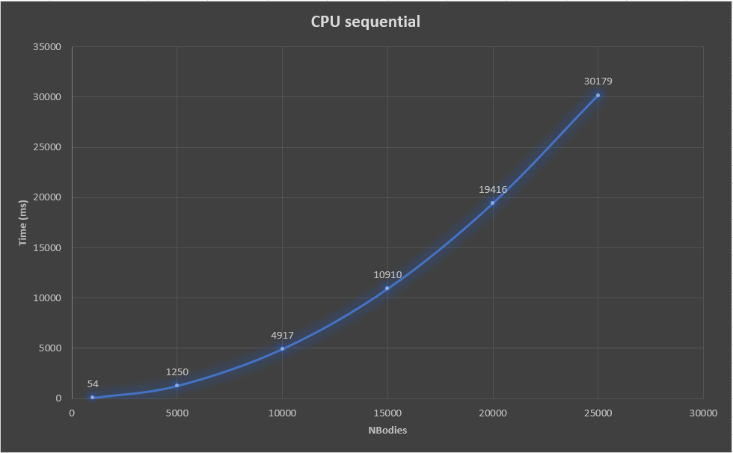

**N-Bodies with Naïve Result (Parallel)**

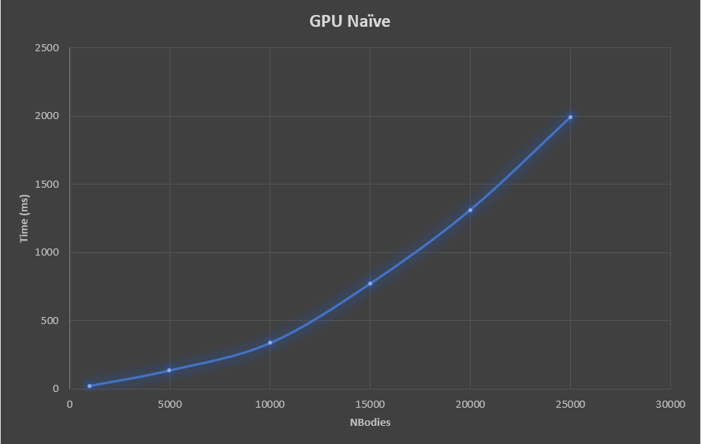

**N-Bodies with Barnes-Hut**

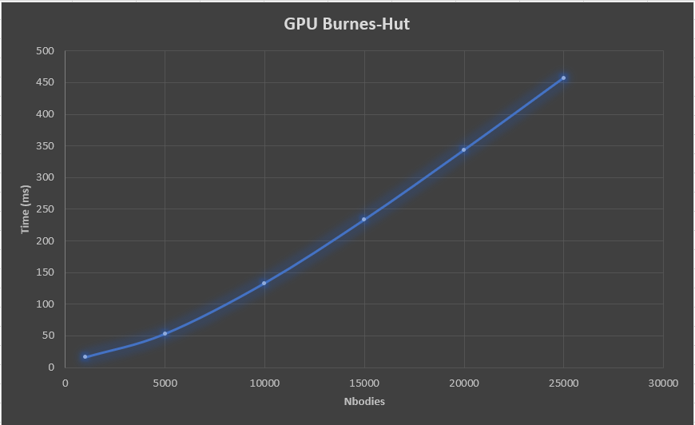

**Over All Result**

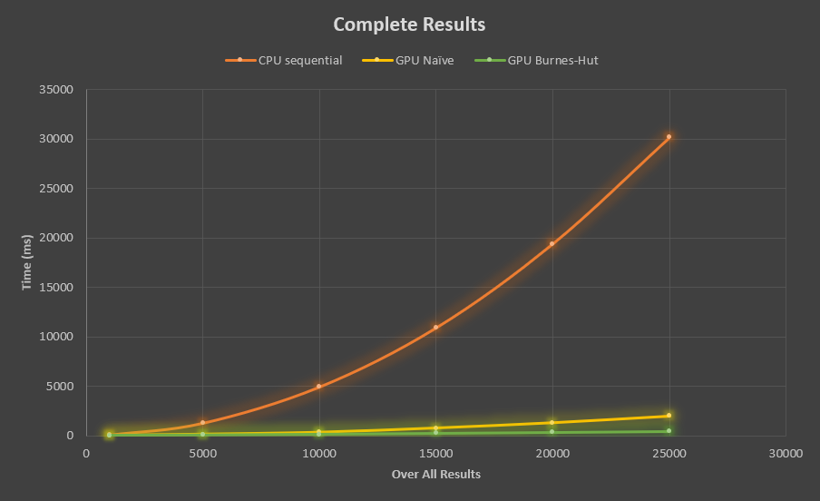

Form above plot It is clear that Burnes-Hut take lesser time if we compare it with Naïve and Sequential approach.

Benchmark:

Benchmark has generated with data give in paper and data generated by my system, base on hardware comparison

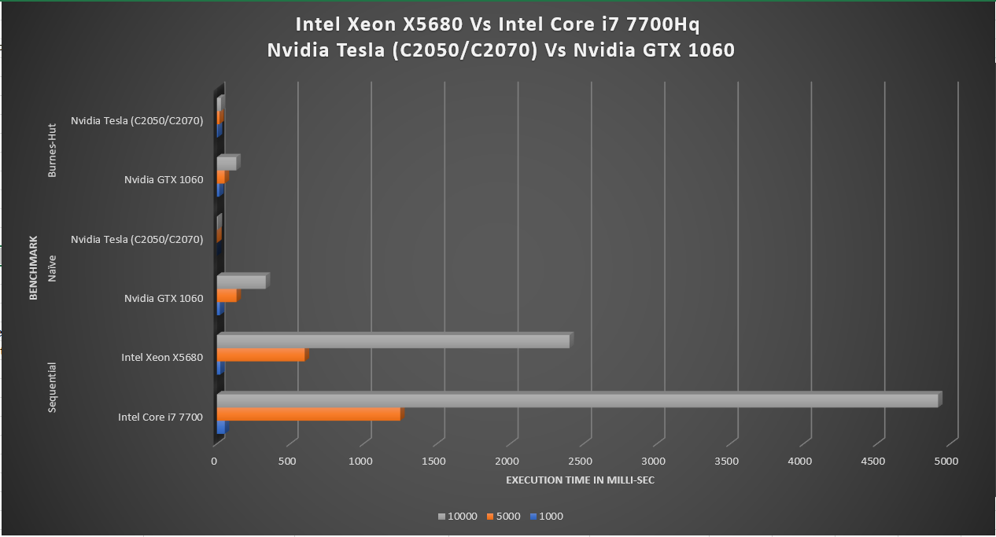

Lower Is better

Above results shows that Nvidia Tesla (C2050/2070) perform better than Nvida GTX 1060. They use more than 3 Tesla unit and I use only 1 GPU for this computation. This might be reason of lower speed than Tesla.

Intel Xeon X5680 having 6 Cores and 12 Logical Processor with clock speed of 3.6Ghz and I have Core i7-7700Hq with 4 Cores and 8 Logical Processor with clock speed of 3.8Ghz. due to less hardware resource my system perform slower than provided results.